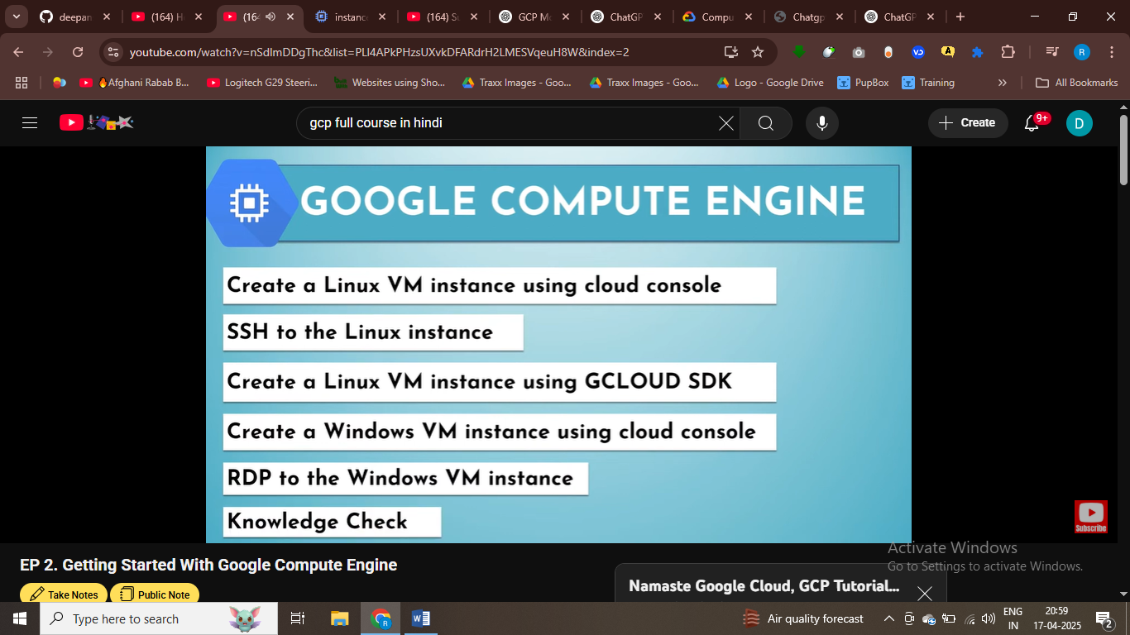

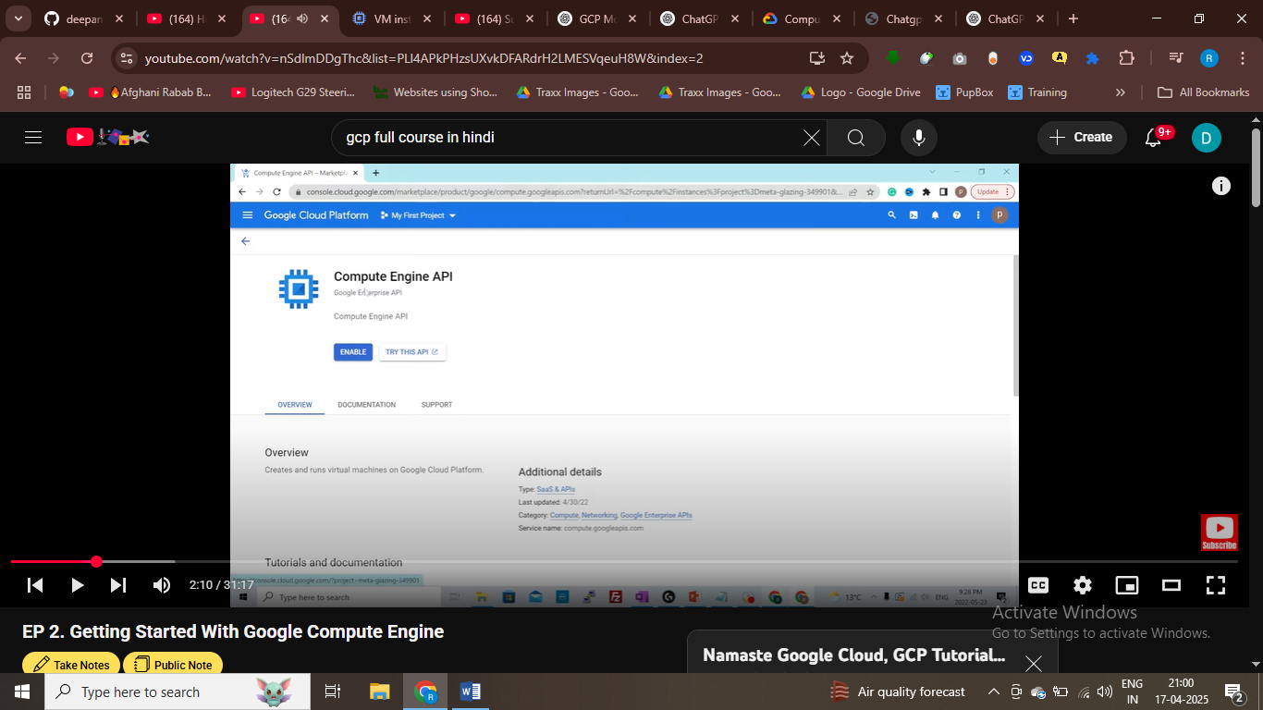

To enable the compute engine service we need to enable the compute engnine api

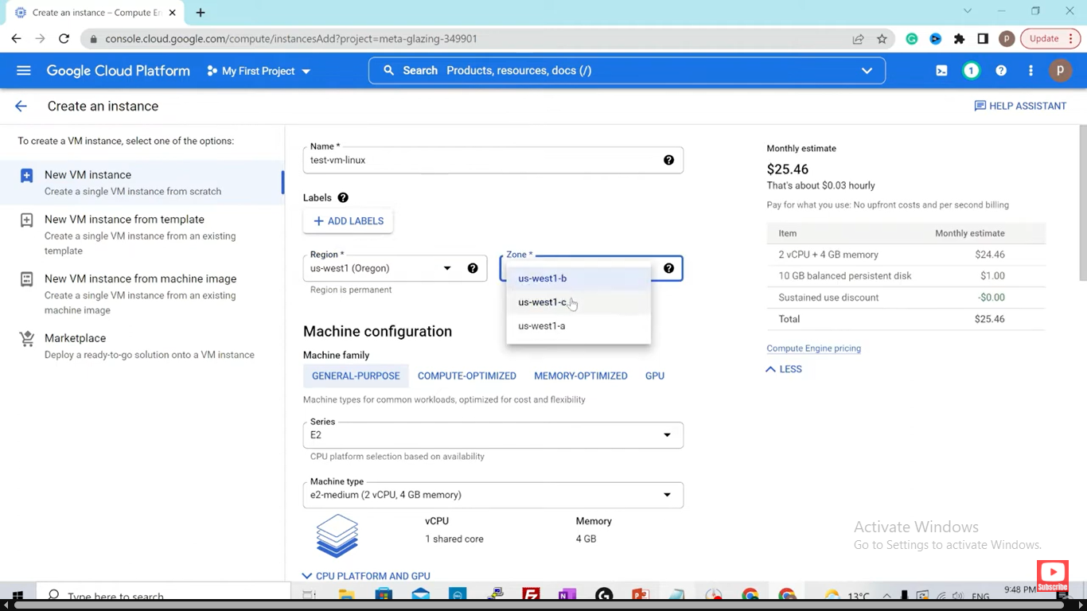

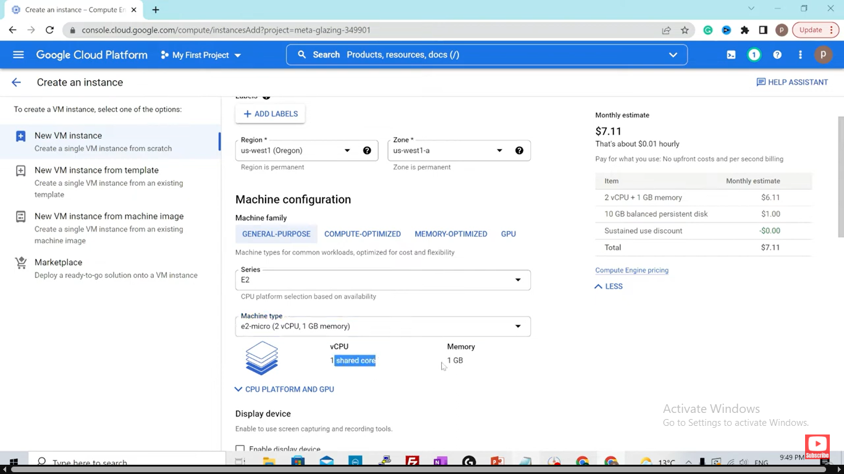

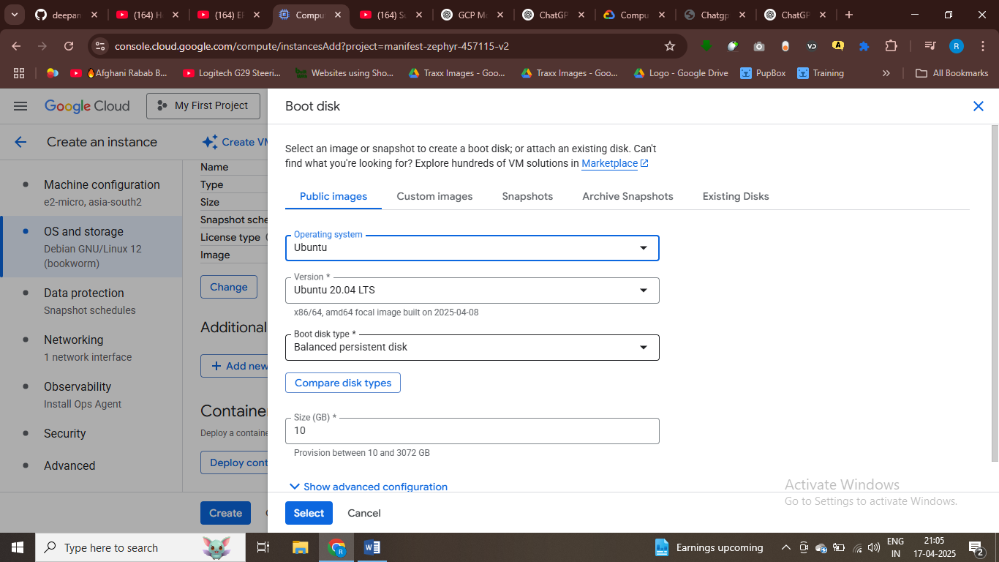

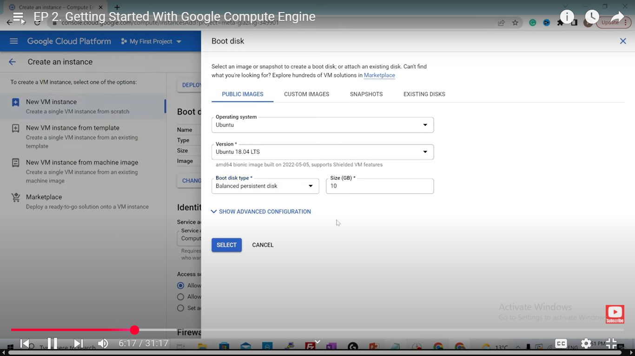

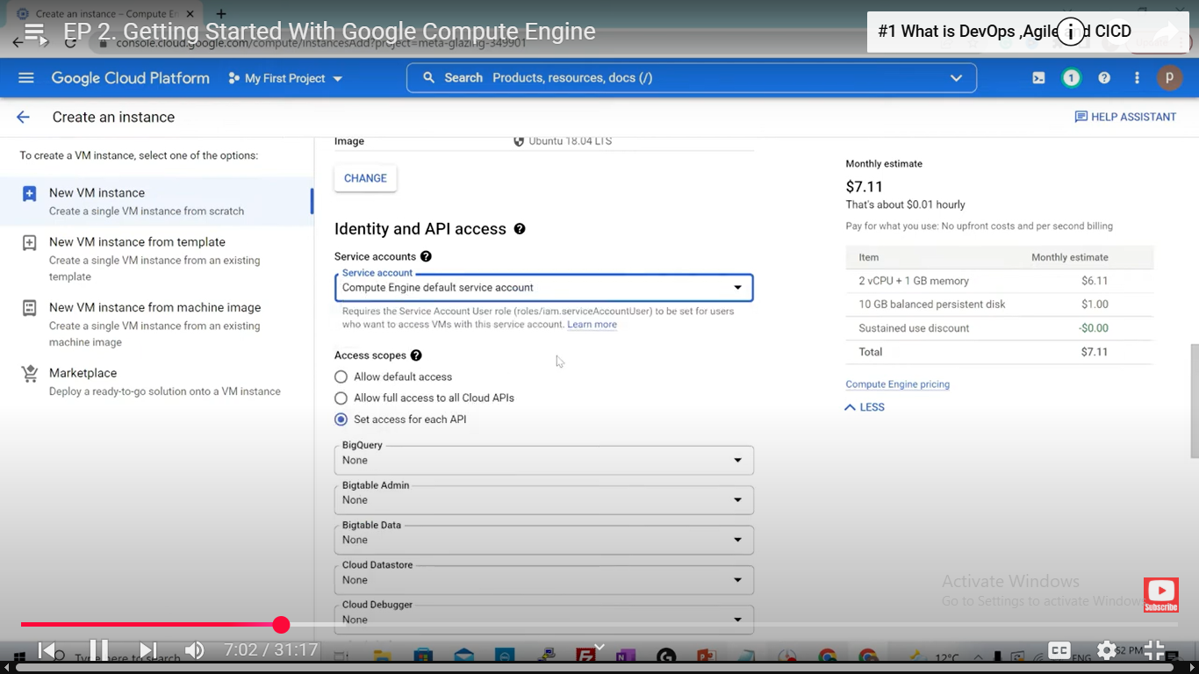there is service account created with the VM – by default it creagted

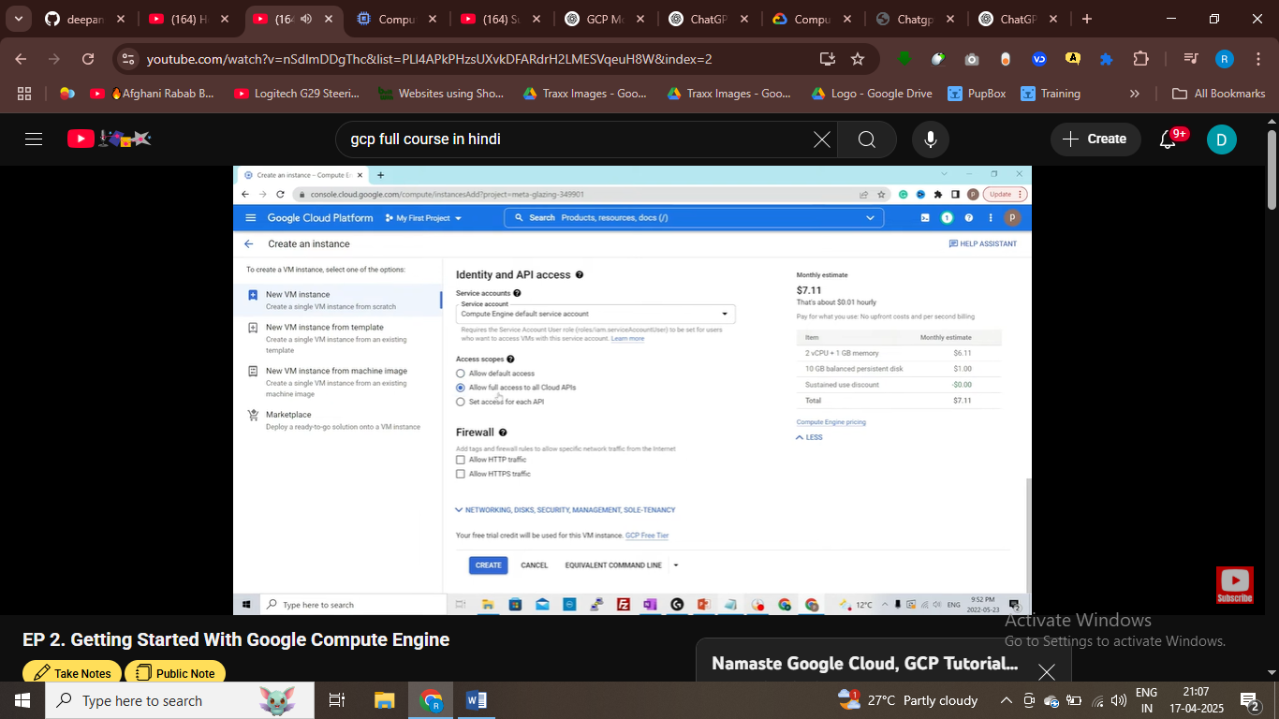

It define how your vm connect with other aws services and how it work with other aws services

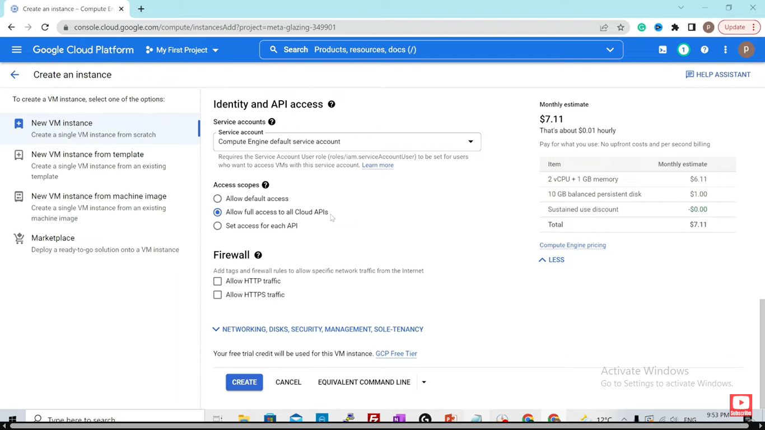

# compute engine api will able to connect and work with all other aws services

If we have web appn and we want that appn to be publicly accessible we can enable http and https

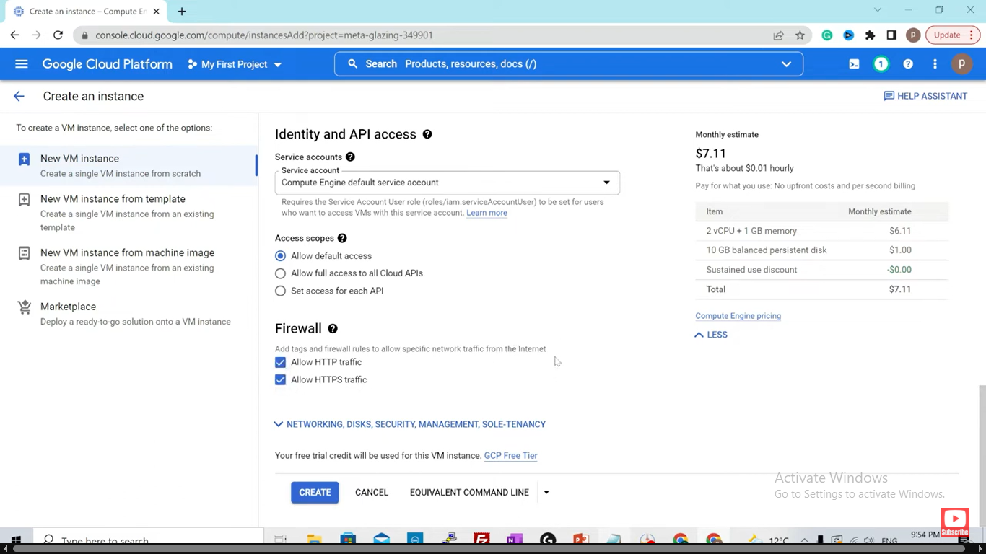

By default if isntnace delted data disk is there – with the instance only

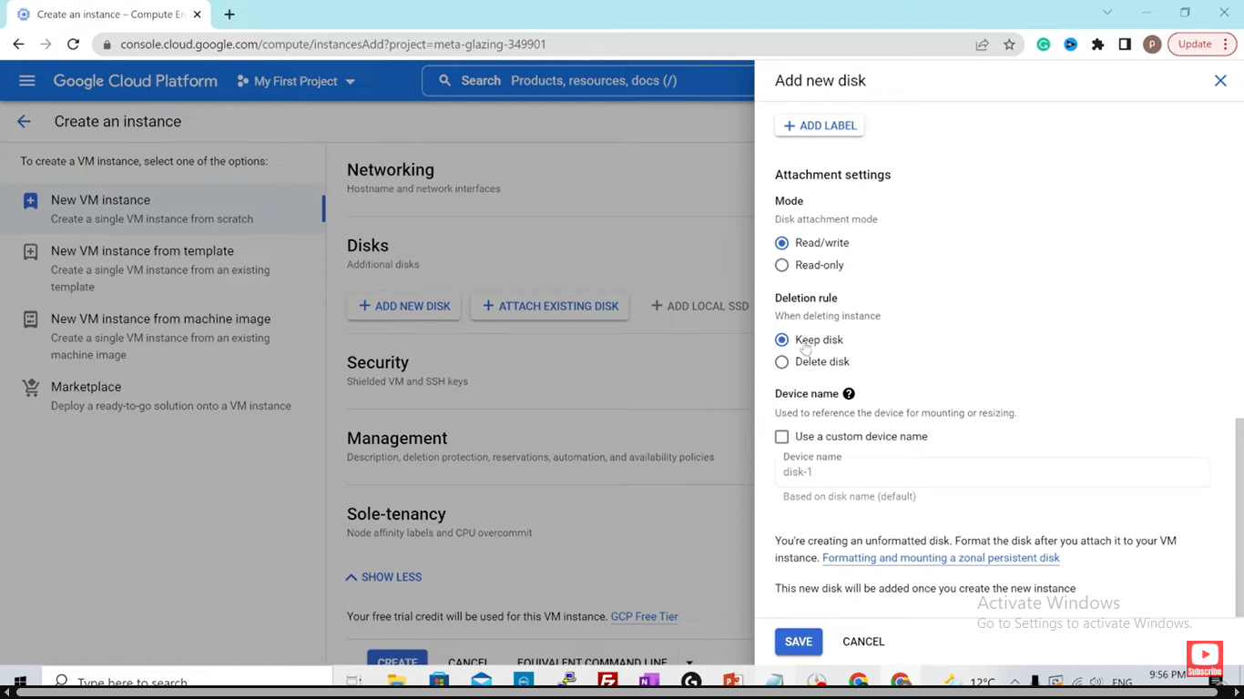

Delete the disk if instance delted

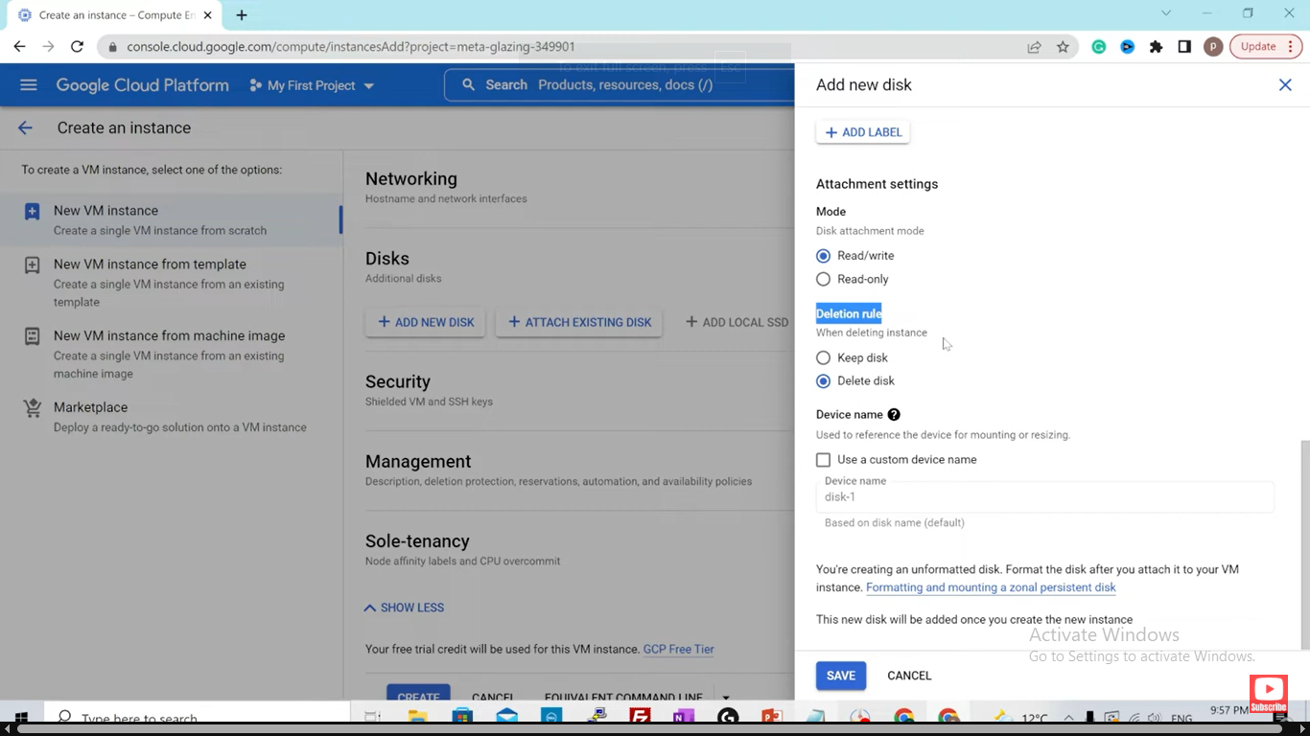

Networking and securitu

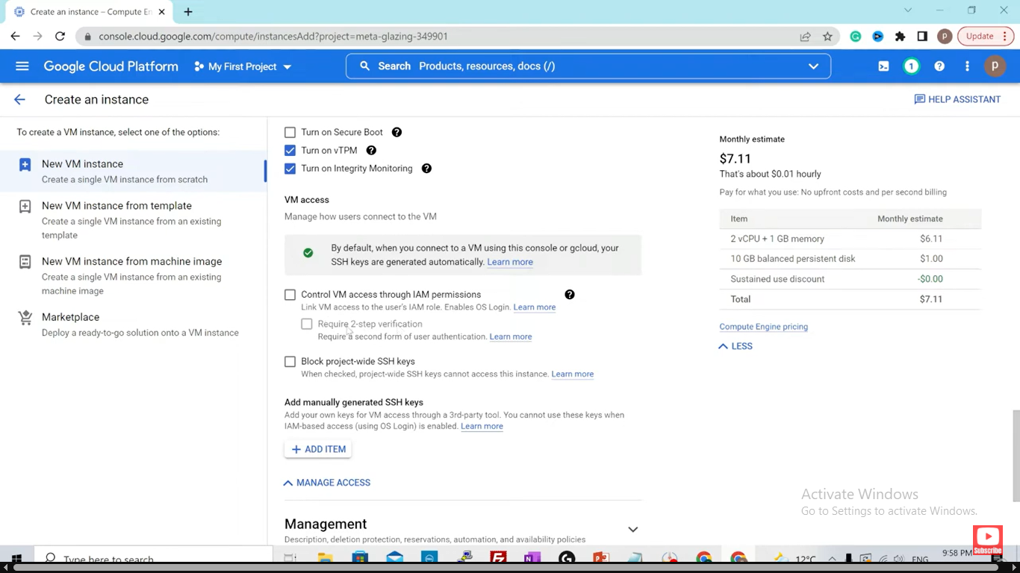

Script executed when the vm is up and running

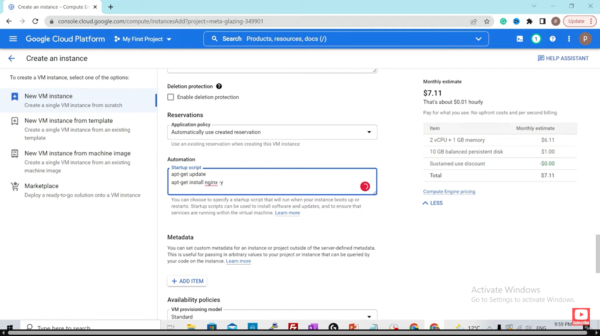

This cmd is executed as the vm is up and running

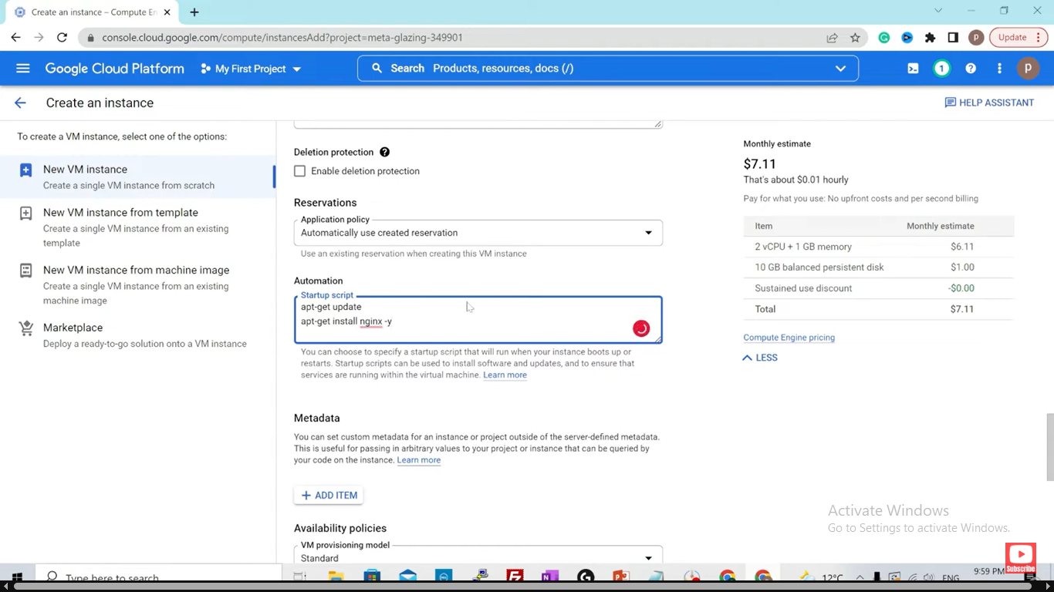

Spot instance is lowcost and limited functionality

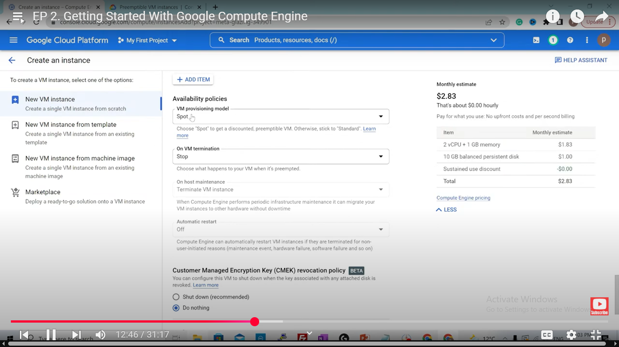

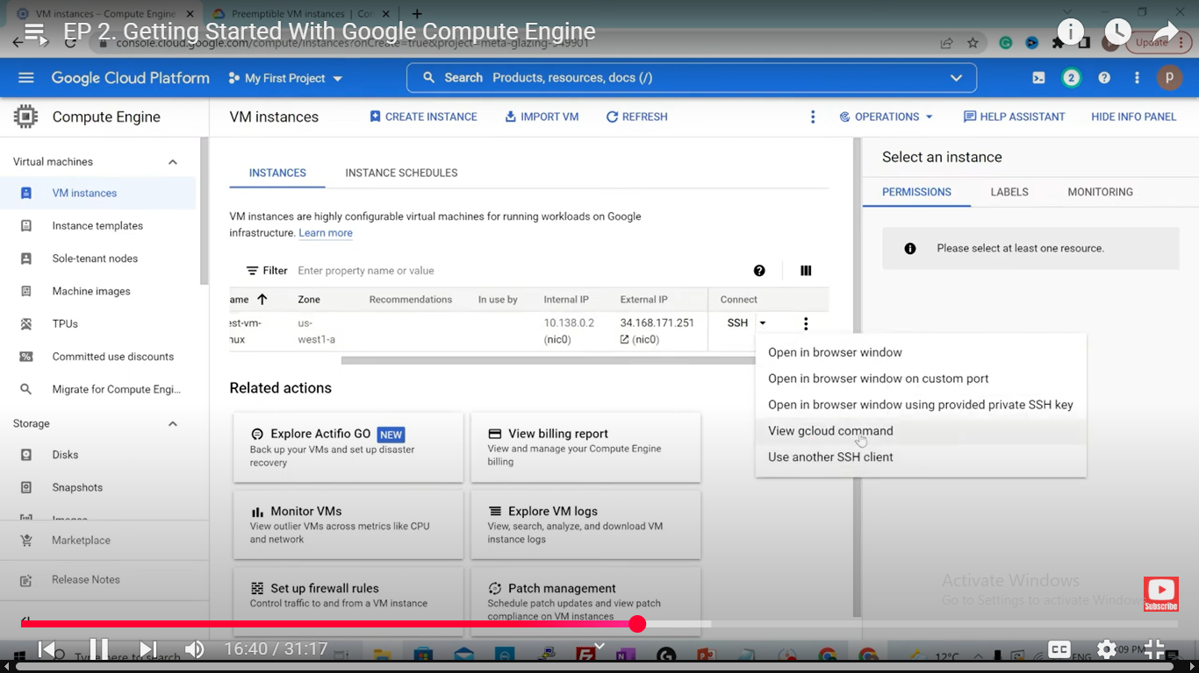

I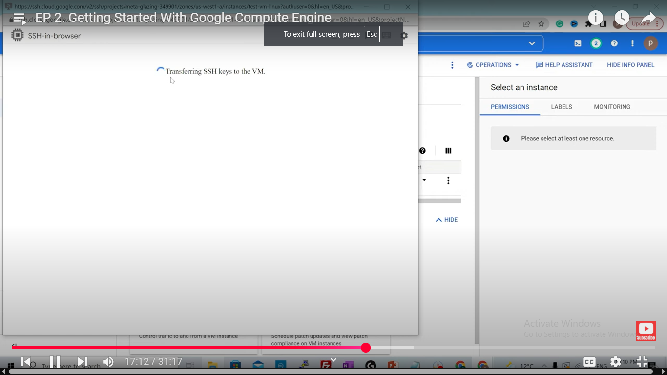

It will automatically genenrate those keys and transfer to the vm – in this we can ssh into machine

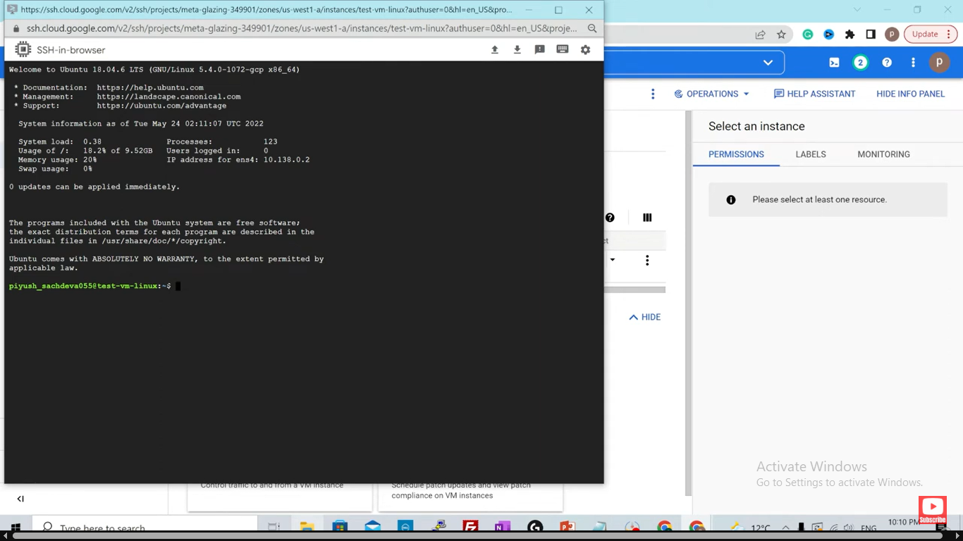

Ssh using gcloud

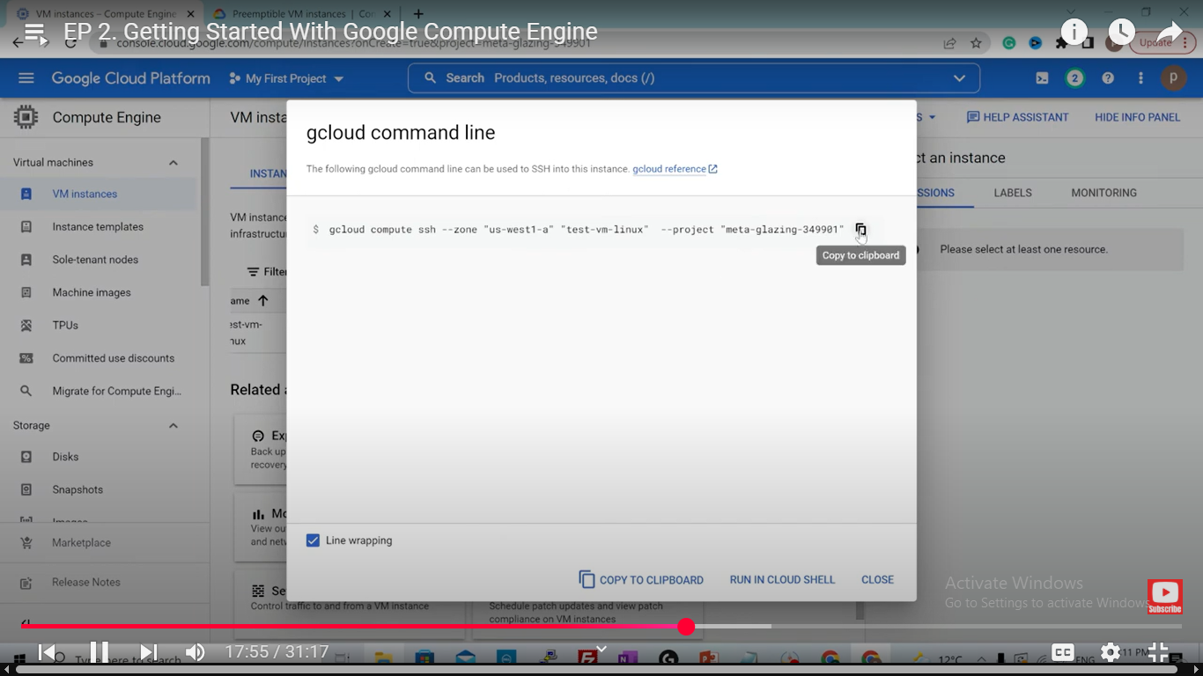

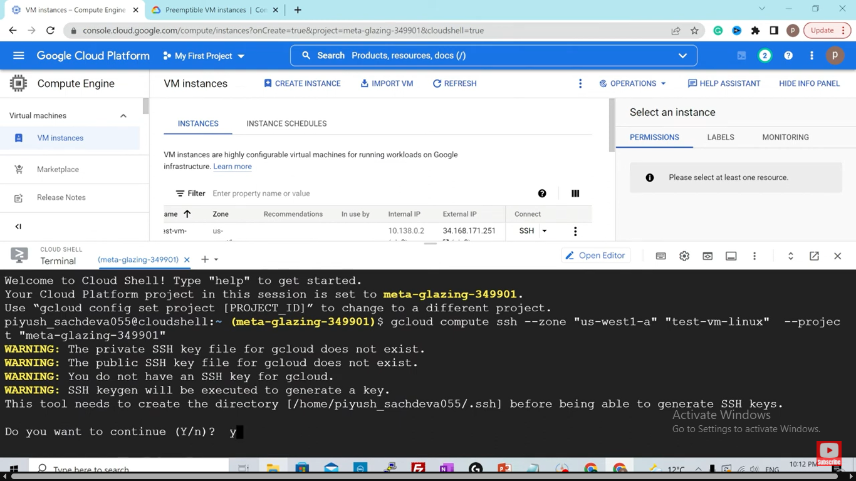

Ssh using gcloud cmd

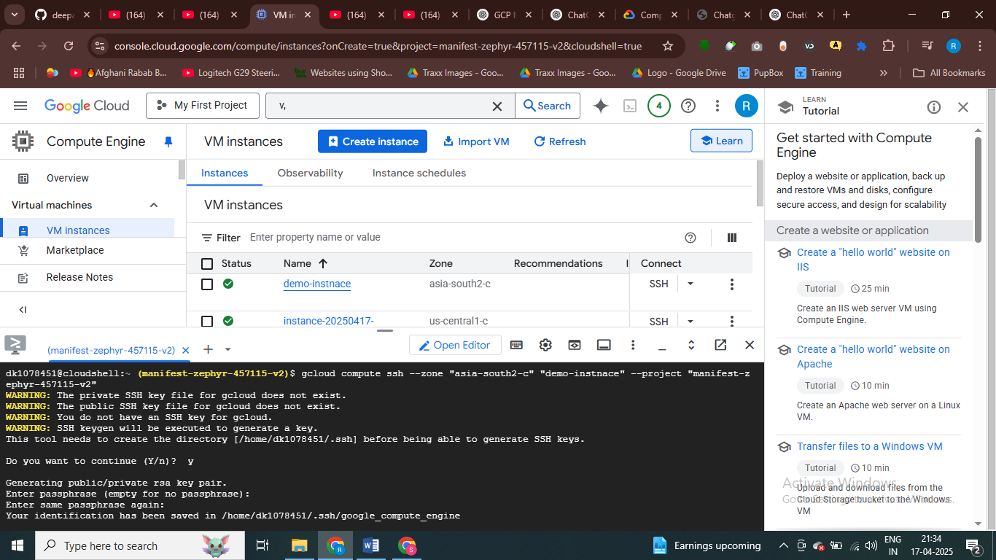

# ssh into cloud using gloud cmd line

This is internal ip for the VM

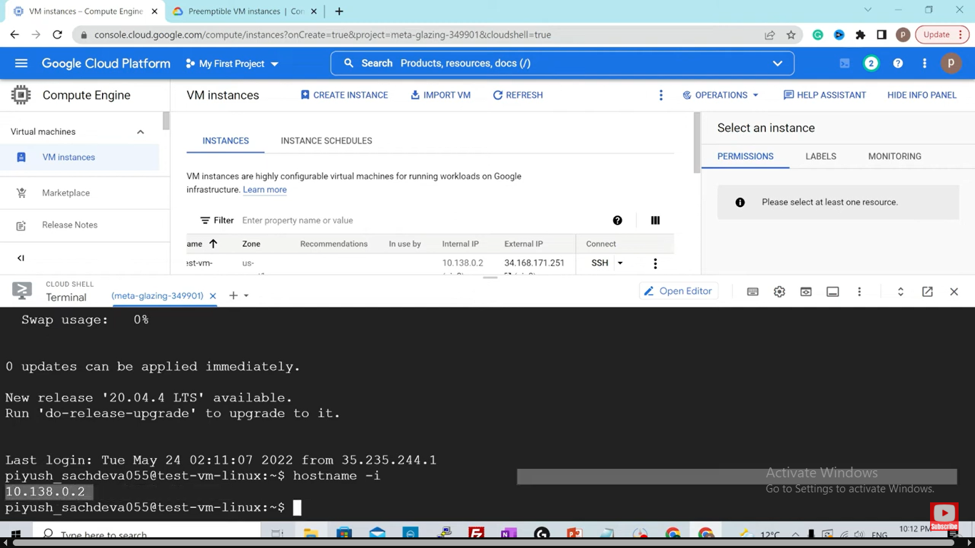

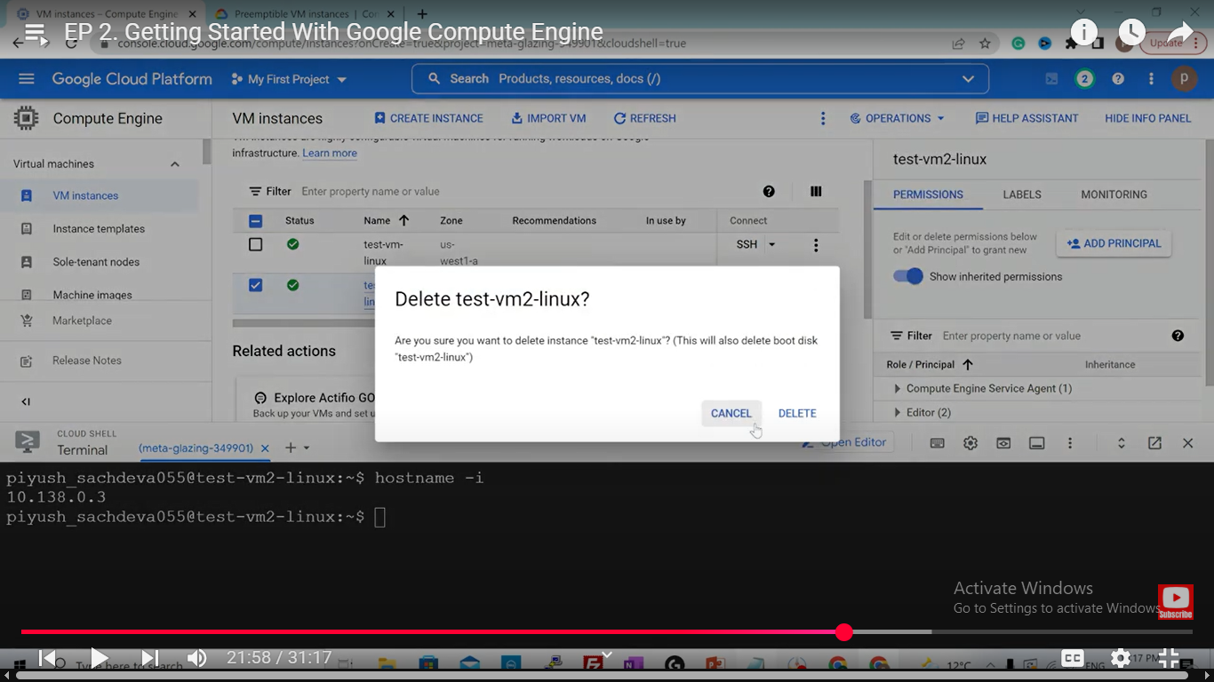if someone accedntly delete the VM

If you want to avaoid accidental deletion

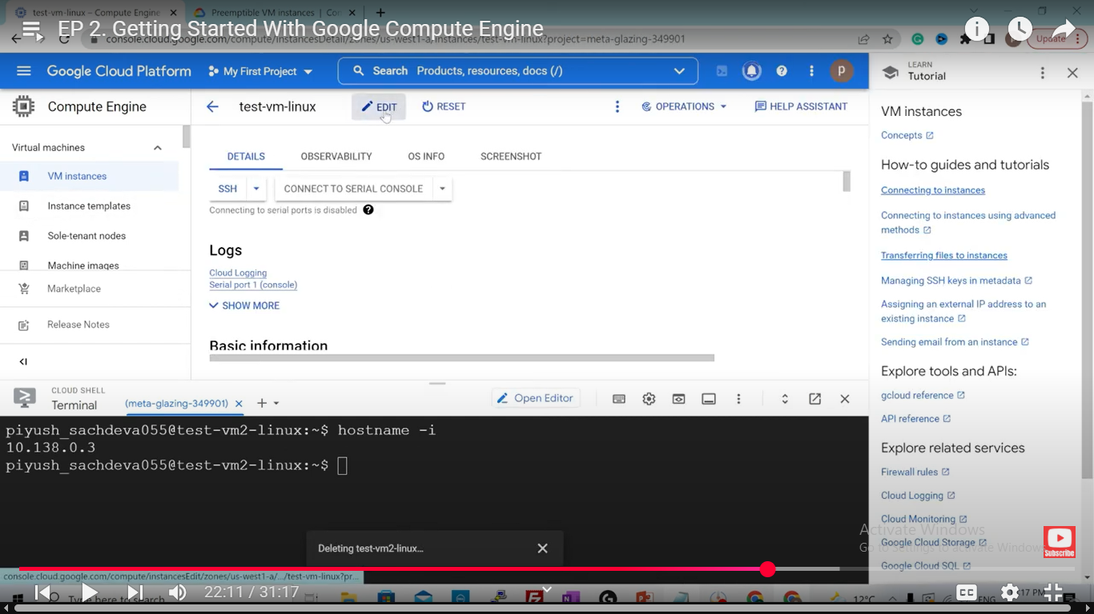go to the vm and prevent this vm from accidently deltion’

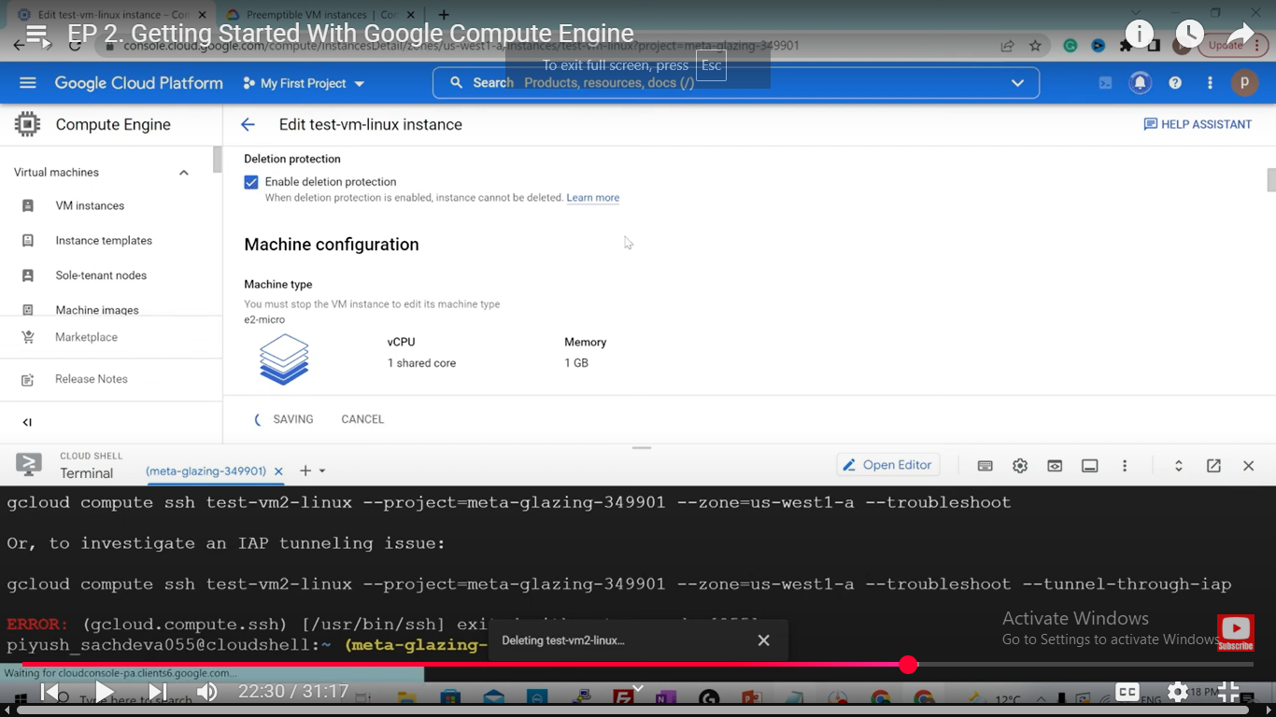

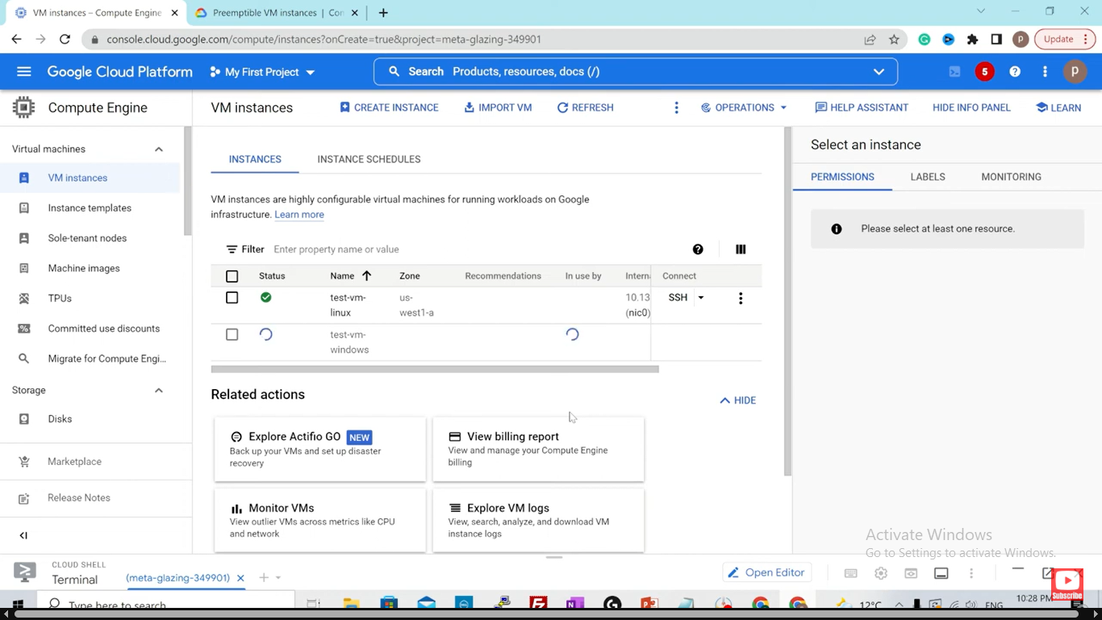

Createing a window vm and we do rdp in window vm – we don’t do ssh into window vm

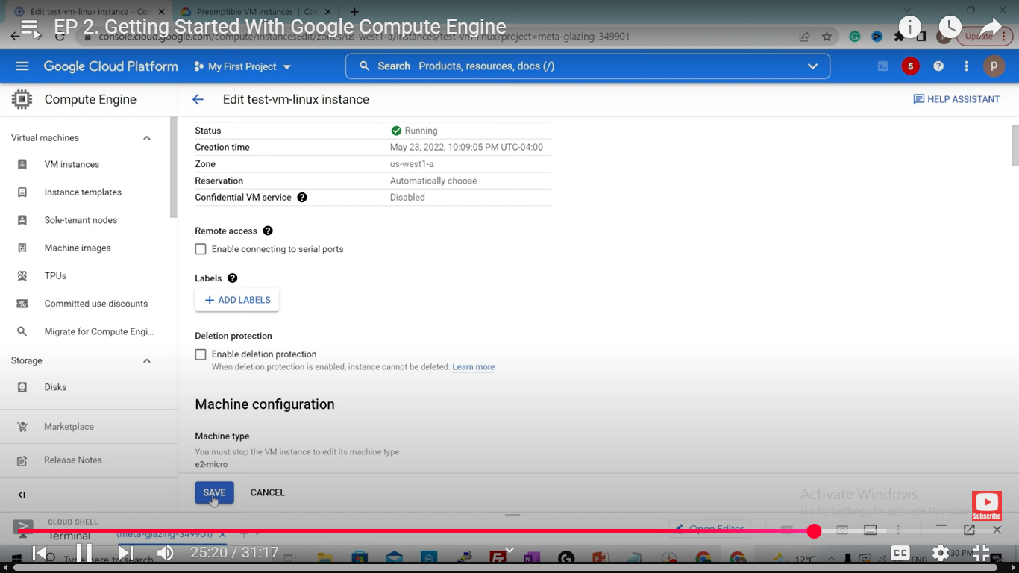

To login into window ec2 instnace use rdp client

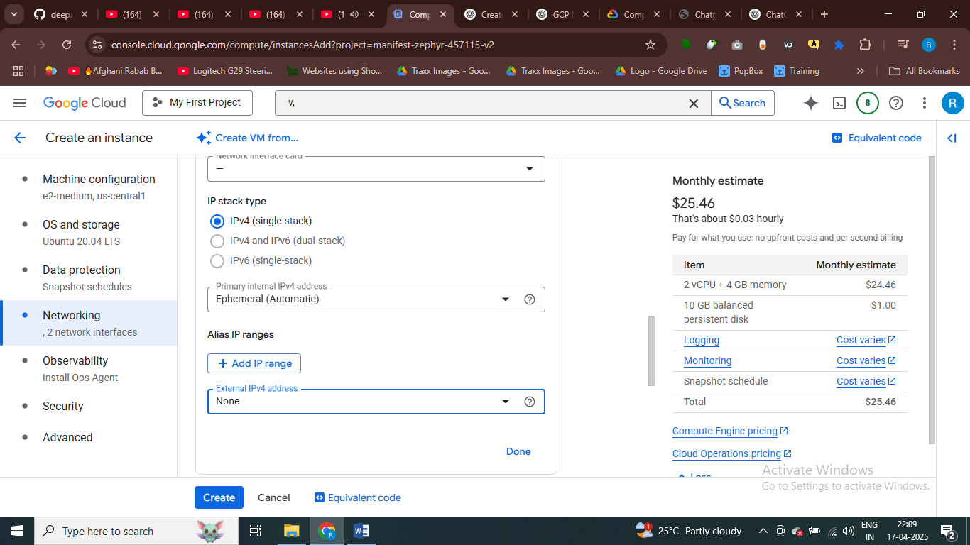

Set external ip are none

**Step 4: Set Up SSH Access to the Private VM**

Since the VM is private (no external IP), you'll need another VM with a public IP to act as a **jump host** to access the private VM.

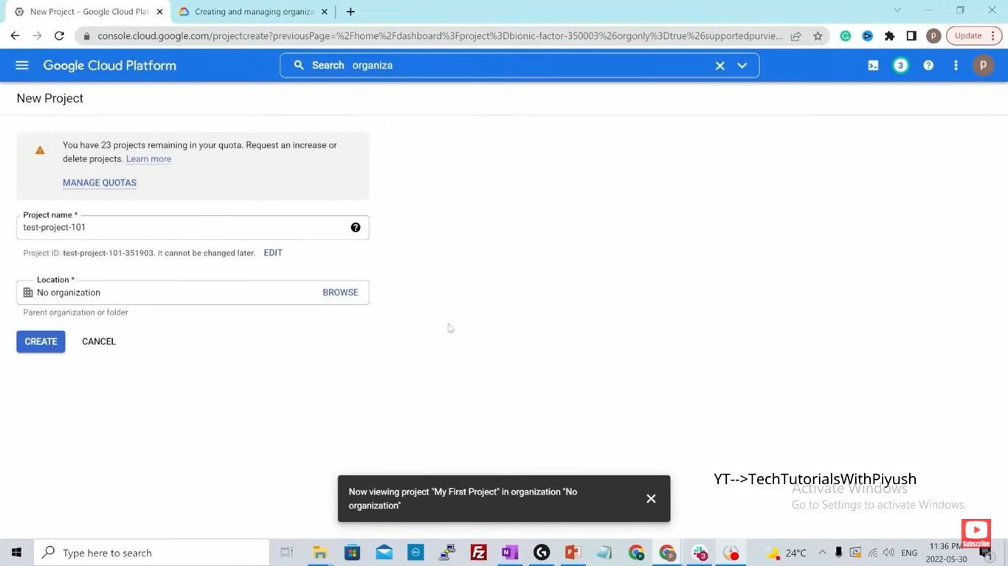

Inside project everything is located

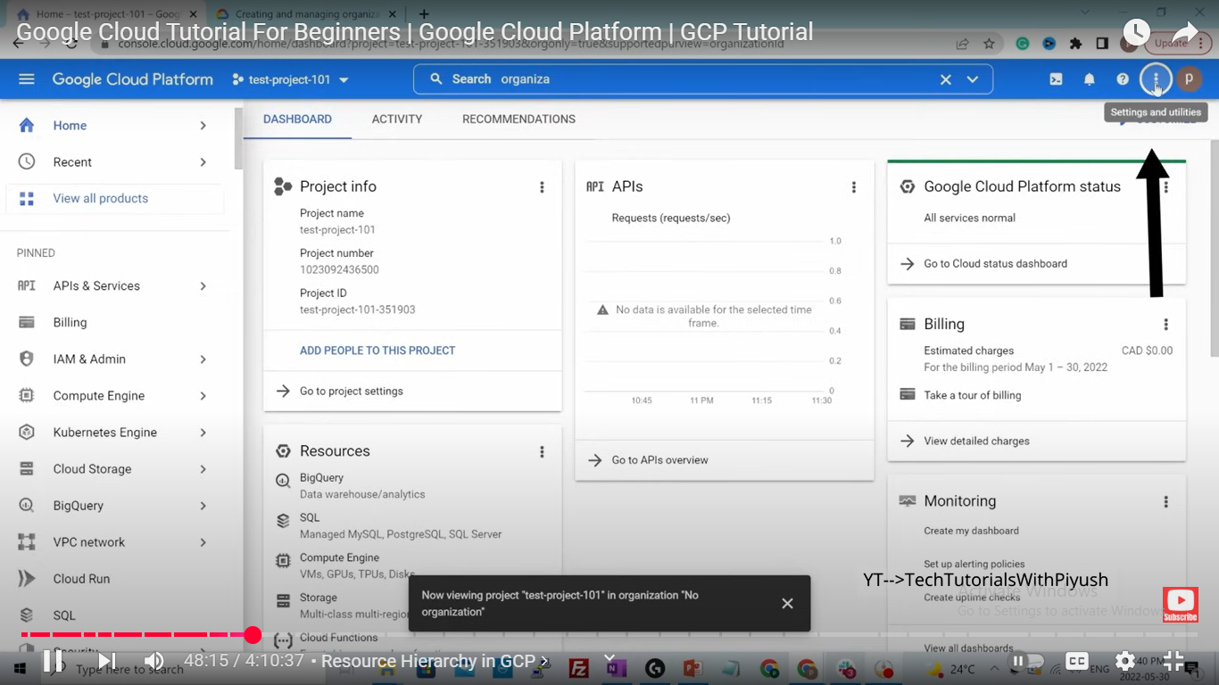

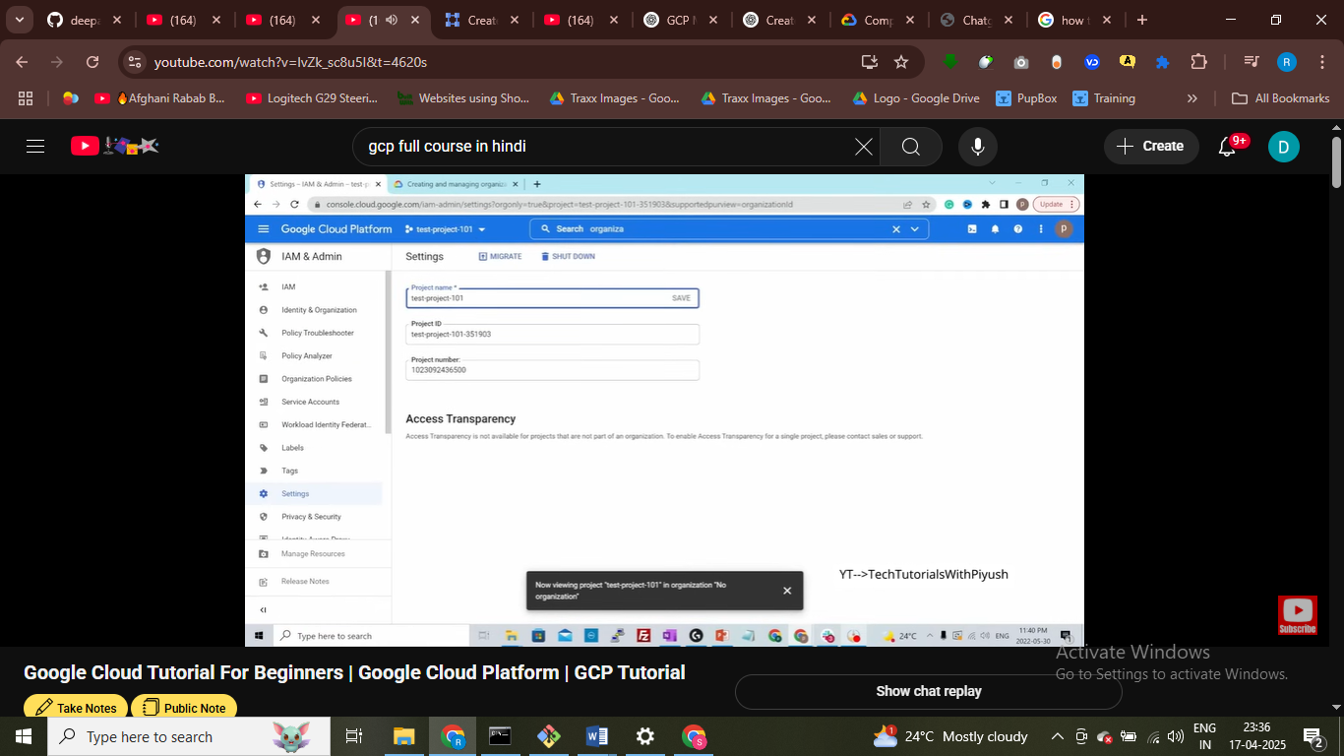

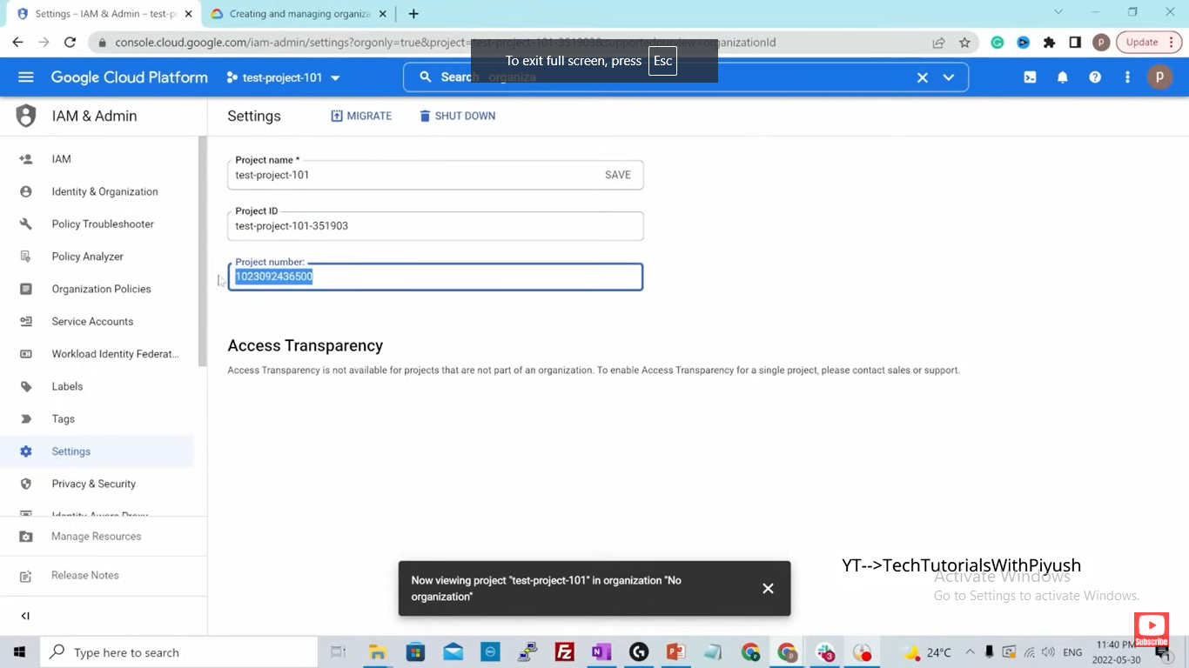this is project id we have , isndie everything is created

Every resource is perent inside this

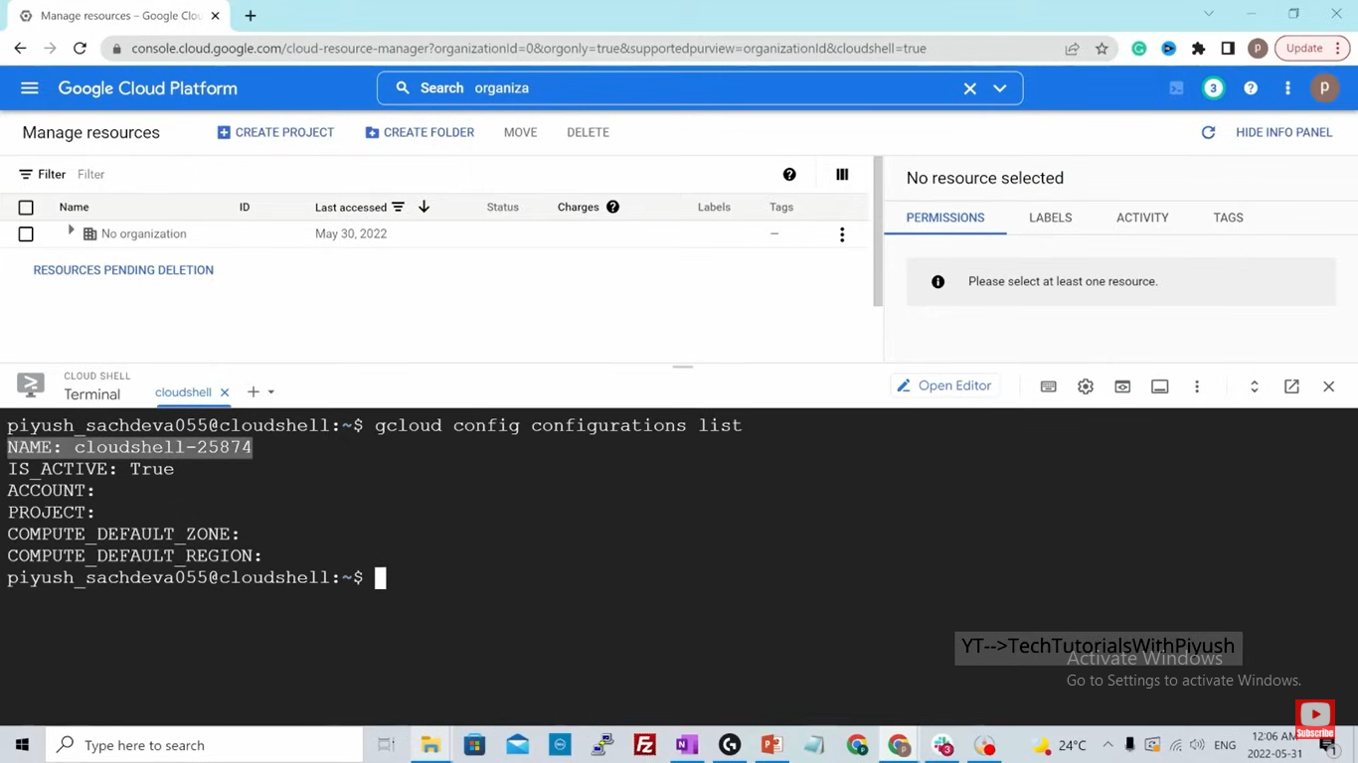

Write now you are in proejcta of configuration

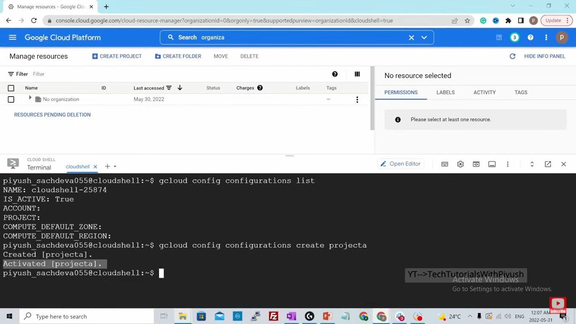

Intenal ip accessible only isndie via machine not with outside –

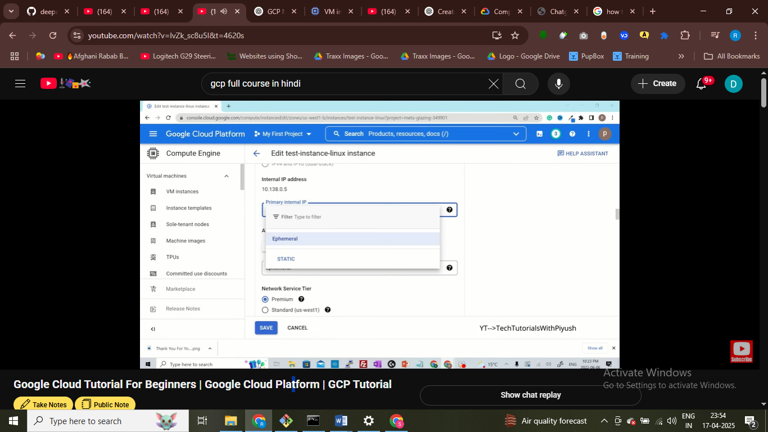

Ephermal ip addres change when you start and stop the aws servce static ip address is fixed

